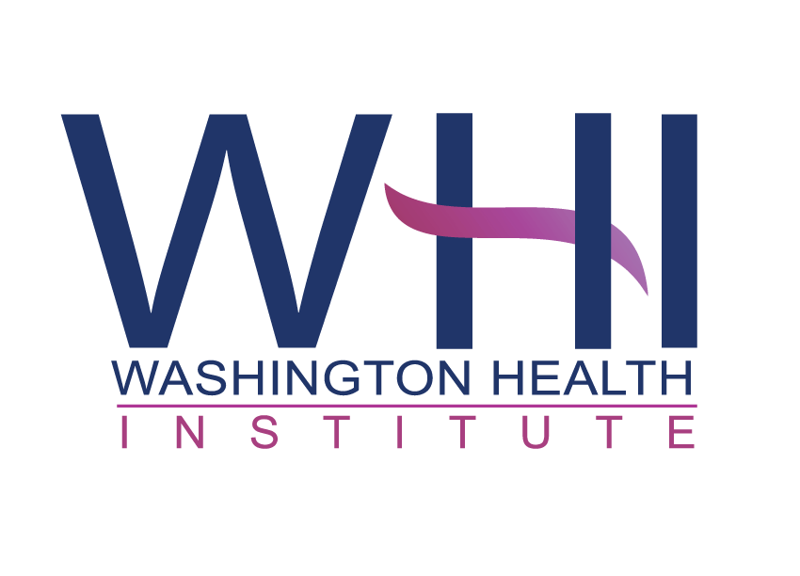
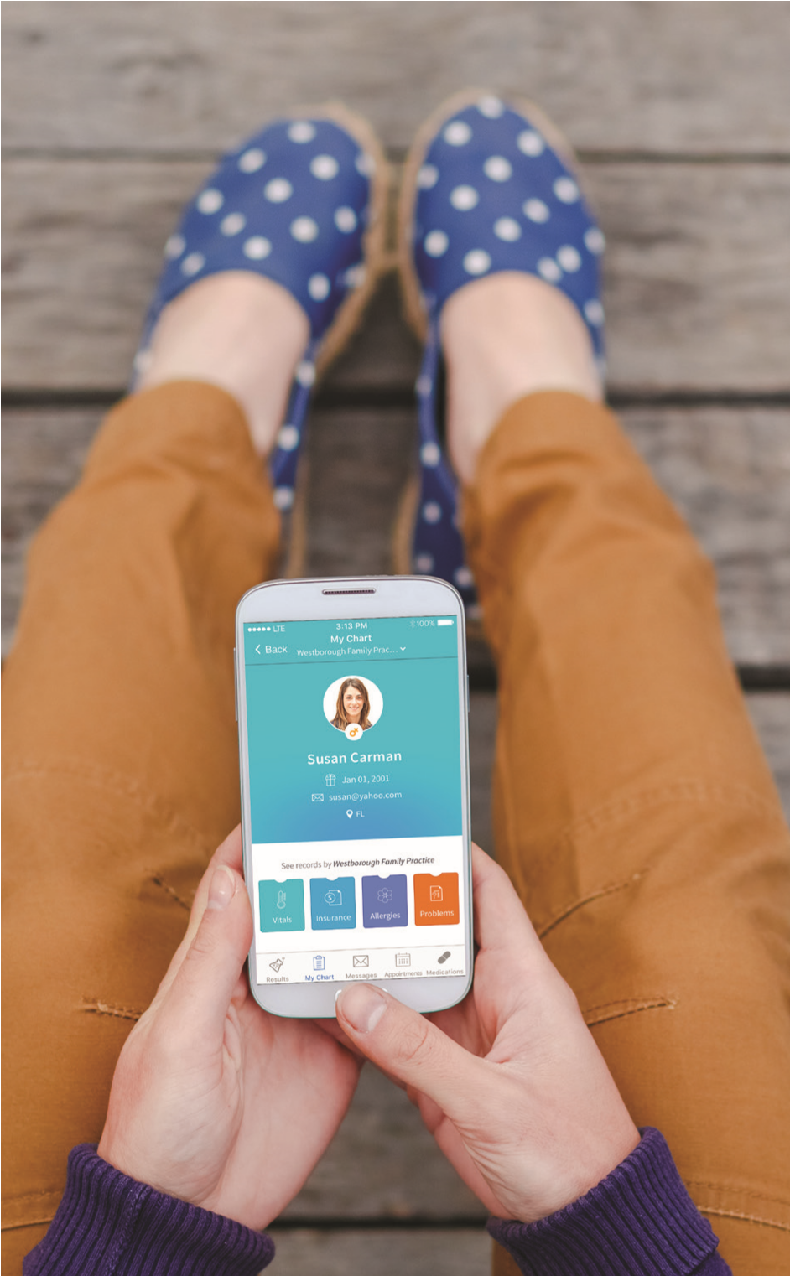
Washington Health Institute
It’s Your
Health Record
Get access. Anytime. Anywhere.
DOWNLOAD THE FREE APP TODAY
LOVE IT? RATE US!
Need to sign up?
Forgot your credentials?
Ask Us!
Health and Online Wellness
1140 Varnum St NE PMB 203
Washington, DC 20017

202-525-5175

Web Address: dc-whi.org

To access your account from the web address, click the Patient Portal link and enter your username (email) and password.
Practice Code:

ADDGCD

To access your account from the healow app, use the practice code above and enter your username (email) and password.
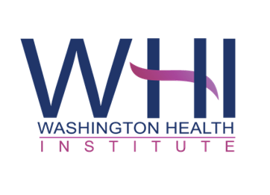
Health and Online Wellness
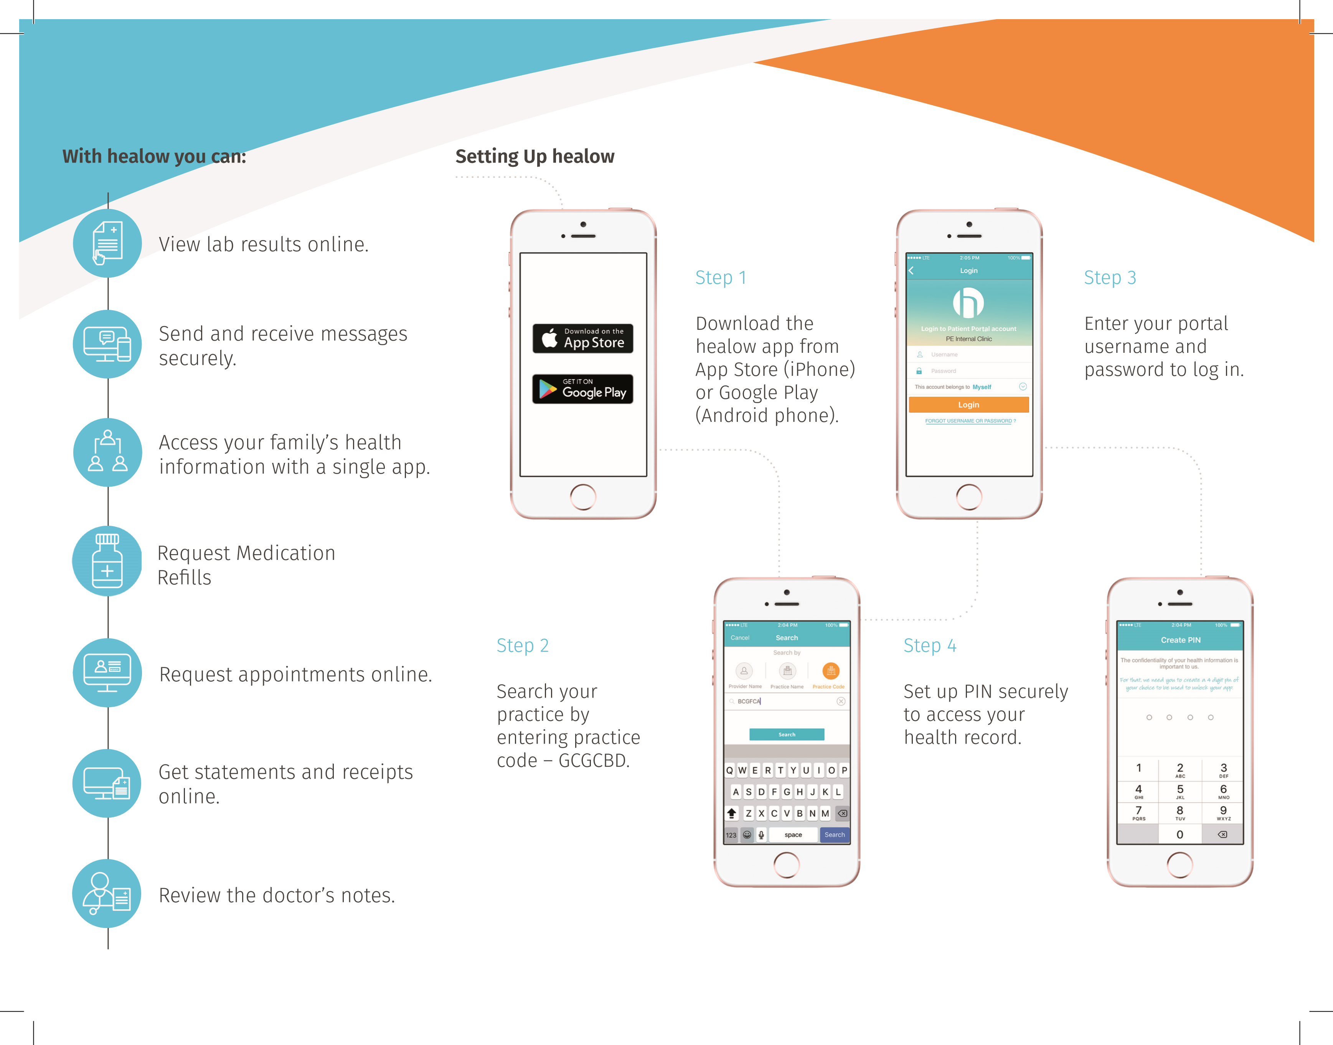
ADDGCD

